Guided Capstone Two Project Report: An investigation of Big Mountain Resorts pricing and facility use strategies for profit maximization

Big Mountain Resort currently sets its ticket prices based on an assumed premium above the average of other local resorts, and management was concerned they were failing to capture the complexities of their competitive advantages. They needed a more data-driven and granular way of analyzing their assets and setting prices.

The first step of building such a model was exploratory data analysis and cleaning. It was determined that weekend and weekday prices were collinear enough that we only needed to use one as our feature of interest. Additionally, we were able to drop a number of features because of either lack of variation or lack of data, larger chairlifts and trams. A thorough analysis of what state each resort was located in also revealed that it could likely be ignored as well, once population density, size, etc. were accounted for.

Once pre-processing was completed two different models were built to predict recommended ticket price - a simple linear regression and a random forest. When directly compared, it was found that the latter had a Mean Absolute Error of (roughly) $10.40 which was a (roughly) $3.75 improvement over the linear regression.

In figure 1 below you can see that fast 4-person chairlifts, # of runs, acres of snow making capacity and ft. of vertical drop from summit to base were the most significant features, which was shared in common between both of the tested models.

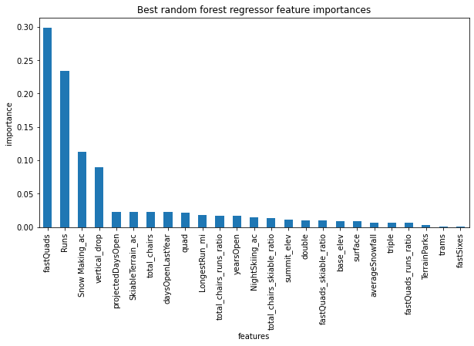

**Fig. 1**

Additionally, Big Mountain is at the very high end of several of these features, as seen in the figures below. This is why the model predicts that Big Mountain could support a ticket

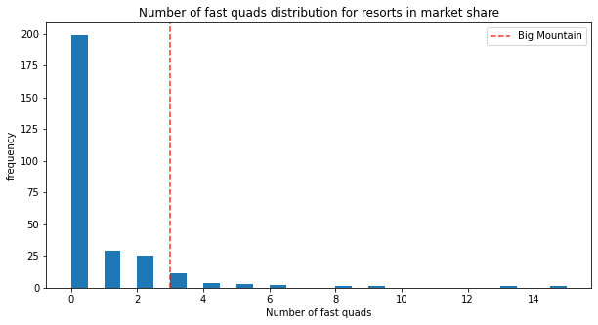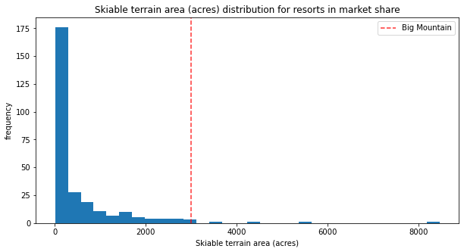

**Fig. 2 Fig. 3**

price should be roughly $17 higher than it currently is. The model also suggests that adding runs, lifts, and particularly snow making area could significantly increase revenue. Adding a run, increasing the vertical drop by 150 feet, and installing an additional chair lift could give support for a $1.55 increase in the ticket price, leading to a predicted $27,083.33 of additional revenue. If two additional acres of snow making area the acceptable ticket price rises an additional $1.99 for $34,746.38.

For further consideration, if the Big Mountain indends any run closures it's important to be aware that ticket price should not decrease linearly with fewer runs. There is a considerable drop off in recommended ticket price at 3 run closures, 6 run closures, and 9 run closures. This suggests that if there's a plan to reduce the number of lifts these cutoff points be kept in mind (ie: if they plan on closing 1 they may as well close 2, etc.)